

INTERNATIONAL SCHOOL OF MANAGEMENT & TECHNOLOGY

**ASSIGNMENT COVER SHEET**

|  |  |  |  |
| --- | --- | --- | --- |
| STUDENT DETAILS | | | |
|  | | | |
| Student ID |  | **Reg No.** |  |
| Family Name | YADAV | **Given Name** | RUPESH KUAMR |
| Enrolment Year | 2022 | **Section** | C |
| Semester | FIRST | **Email** | Kif22.rky@ismt.edu.np |

|  |  |  |  |  |
| --- | --- | --- | --- | --- |
| UNIT DETAILS | | | | |
| Unit Title | **Professional practice** | **Unit Code** | **L/618/7398** | |
| Assessor Name | **BHARTI ACHARYA** | **Issued Date** | **28/11/2022** | |
| Assignment Title | **YETI EXPLORATION AND SPACE TOURISEM** | | | |
| Assignment No |  | **Submission Date** | | **27 JAN, 2023** |
| Qualification | **BTEC HND IN COMPUTING** | **Campus** | | **ISMT** |





**STUDENT ASSESSMENT SUBMISSION AND DECLARATION**

When submitting evidence for assessment, each student must sign a declaration confirming that the work is their own.

|  |  |  |  |
| --- | --- | --- | --- |
| Student Name | RUPESH KUMAR YADAV | Assessor Name | BHARTI ACHARYA |
| Issue Date | 28/11/2022 | Submission Date | 27 JAN, 2023 |
| Programme | BTECH / HND IN COMPUTING | | |
| Unit Name | PROFESSIONAL PRACTICE | | |
| Assignment Title | YETI EXPLORATION AND SPACE TOURISEM | | |

**Plagiarism**

Plagiarism is a particular form of cheating. Plagiarism must be avoided at all costs and students who break the rules, however innocently, may be penalized. It is your responsibility to ensure that you understand correct referencing practices. As a university level student, you are expected to use appropriate references throughout and keep carefully detailed notes of all your sources of materials for material you have used in your work, including any material downloaded from the Internet. Please consult the relevant unit lecturer or your course tutor if you need any further advice.

**Student Declaration**

I certify that the assignment submission is entirely my own work and I fully understand the consequences of plagiarism. I understand that making a false declaration is a form of malpractice.

Student signature: Rupesh Kumar yadav Date:

Pearson Education 2018  
Higher Education Qualifications

Table of Contents

Activity 1 5

Introduction 5

Communication 5

Communication styles: 5

1. Passive communication: 6

2. Aggressive communication 6

3. Assertive communication 6

4. Passive-aggressive communication: 7

Communication types 7

Verbal communication 7

Oral communication: 7

Written communication 8

Nonverbal communication: 8

Visual communication: 9

Interpersonal communication 9

Effective time management skills 9

The training event 11

Guidelines of event 11

Justification for Schedule of 3 days program 11

Event description 12

Problem solving technique: 13

Brainstorming: 13

SWOT Analysis: 13

Drill Down Technique 14

Six Thinking Hats Represents: 14

Critical Reasoning solving problem 15

Overall learning of the event 16

Application and Use of Methodologies 16

Feedback form 17

Conclusion 18

Activity 2 18

Introduction 18

Presentation Slides 18

Importance of team dynamics in success of group work 25

Importance of team dynamic 26

Responsibilities and Work of our team members 27

Team Leader 27

Scientists: 27

Engineers 27

Medical Doctors: 27

Data Analysts: 27

Communication and Public Outreach: 28

My role in a team 28

Area of development in my role: 28

My contribution to sharing the goal 29

Failure of group work in conference 29

Objective on achieving goals to make successful conference 29

Interpersonal skills 30

Effectiveness and application of interpersonal skill 30

Conclusion 30

Activity 3 31

Introduction 31

Continuing Professional Development (CDP) 31

Importance of CDP 31

Motivation contribution to own learning. 32

Motivational Theory 33

Maslow's Hierarchy of Needs: 33

Impact on workplace 34

Two-Factor Theory of Herzberg: 34

The McClelland Theory of Need 35

Vroom’s Expectation Theory 35

Impact of CDP in my workplace 36

Development plan that outlines Responsibilities 36

Responsibilities 37

Development plan table 37

Roles of CDP 39

Development planning in building motivational 40

Conclusion: 41

# Activity 1

# Introduction

I'll utilize tanning in the aforementioned scenario to demonstrate communication in the fictitious situation where I'm a junior practice administrator. I can provide an explanation of verbal and nonverbal communication styles to help participants in the training event communicate and carry out varied plans and timetables. I'll develop a Yeti Explorations provides the critical thinking environment necessary to manage any problem-solving technique throughout training sessions. communication styles used in professional situations I've been using it to communicate throughout training exercises for decision-making and many more scenarios. The difficult and significant communication training activity is this one.

# Communication

The process of exchanging information, ideas, or thoughts through speaking, writing, or some other medium is known as communication. It is a fundamental human activity that allows people to connect, share ideas, and work together to achieve their goals. Effective communication requires the sender to encode a message and the receiver to decode it while providing feedback. Language, culture, and context all have an impact on the communication process.

## Communication styles:

There are several communication styles that are included below:

## Passive communication:

Passive communication is a style of communication in which a person avoids directly expressing their thoughts and feelings and does not accept responsibility for their actions. Individuals who use passive communication may have difficulty standing up for themselves, may be afraid of conflict or rejection, and may fail to assert their own needs and desires. Passive communication can result in feelings of frustration and resentment, as well as misunderstandings. In some cases, the passive communicator may be exploited or perceived as weak. It can also lead to a lack of trust and respect in a relationship.

Example of passive communication:

* Not expressing one's own thoughts or opinions
* Not arguing with or challenging others
* Excessive apology
* Being unable to make up one's mind
* Keeping your eyes closed
* Using a low voice tone

## Aggressive communication

Aggressive communication is defined as the use of verbal or nonverbal language to intimidate, dominate, or harm others. This includes yelling, using profanity, making threats, or making menacing physical gestures. Aggressive communication can harm relationships and foster a hostile environment. It is critical to communicate assertively rather than aggressively, which means advocating for yourself while also respecting the rights and feelings of others.

## Assertive communication

Assertive communication is a style of communication that allows people to express themselves clearly and directly while also respecting the rights and feelings of others. It is distinguished by honesty, directness, and the ability to set boundaries. People who communicate assertively are able to say "no" when necessary and to advocate for themselves without being aggressive or demanding. They can also actively and empathetically listen to others, express their own feelings and thoughts in a calm and non-threatening manner, and negotiate and compromise effectively. Assertive communication is regarded as a healthy and effective mode of communication because it allows individuals to establish mutual respect and trust in their relationships. It also aids in the resolution of conflicts in a constructive manner.

## Passive-aggressive communication:

Passive-aggressive communication is a style of communication in which anger or frustration is expressed indirectly, through sarcasm or subtle put-downs, rather than directly. This communication style is frequently used when a person feels unable to express their true feelings directly, either due to rejection or conflict. Passive-aggressive communication can be difficult to detect and comprehend because the person may appear compliant on the surface, but their behavior or tone may be subtly undermining or hostile. Passive-aggressive communication can be damage to relationships because it fosters confusion and mistrust, making it difficult to resolve conflicts. It can also make the person on the receiving end feel frustrated, disrespected, and unsupported.

Procrastination, forgetting to do things, making excuses, and giving backhanded compliments are all examples of passive-aggressive communication.

## Communication types

There are different formats or modes of communication. Each format has its own set of benefits and drawbacks, and each can be used in a variety of situations depending on the circumstances. It is critical to be able to select the appropriate format for the situation and to adapt one's communication style accordingly.

## Verbal communication

The use of spoken language to convey information and express thoughts and feelings is referred to as verbal communication. It can occur in a variety of contexts, including face-to-face conversations, phone calls, video conferencing, and public speaking.

There are two types of verbal communication:

## Oral communication:

Oral communication is the use of spoken language in person or over the phone. It is a type of verbal communication that provides instant feedback and the ability to clarify meaning through nonverbal cues and tone of voice. One-on-one conversations, group discussions, presentations, and public speaking are all examples of oral communication. It has a wide range of applications, including personal relationships, the workplace, and formal settings such as meetings and conferences. The use of clear, concise, and accurate language is required for effective oral communication. Active listening is also required, which entails paying attention to the speaker and comprehending the message being conveyed. Furthermore, it is critical to be aware of the audience and use language appropriate to the situation and audience.

Written communication:

The use of written language to convey information and express thoughts and feelings is referred to as written communication. It is a type of verbal communication that can take the form of text messages, emails, letters, or reports. It creates a permanent record of the communication, which can be useful for future reference, but it lacks the immediate feedback and nonverbal cues that oral communication provides. The use of clear, concise, and accurate language is required for effective written communication. It requires attention to grammar, spelling, and punctuation, as well as an understanding of the audience and the purpose of the communication. It is also necessary to organize the information in a logical and understandable manner. Visual aids such as images, tables, and graphs can also be used to improve written communication.

Personal relationships, the workplace, and formal settings such as government and legal documents, business reports, and academic papers all use written communication. It is critical to select the proper format and style based on the context and audience.

## Nonverbal communication:

The process of communicating without using words is known as nonverbal communication. It consists of facial expressions, body language, and tone of voice, and it can convey meaning and emotions more effectively than words alone. Nonverbal communication can be conscious or unconscious, and it can be used alongside verbal communication to emphasize or convey meaning that is not explicitly stated in the word.

***Example of Nonverbal communication:***

Facial expressions: Smiles, frowns, and raised brows, can convey emotions such as happiness, anger, or surprise.

Body language: including posture, gestures, and eye contact, can convey emotions such as confidence, defensiveness, or interest.

Tone of voice: Pitch, volume, and pace of voice can all indicate emotions such as anger, excitement, or sadness.

Proximity: Physical proximity between people can indicate the level of intimacy or discomfort.

Touch: A pat on the back or a handshake can convey congratulations, congratulations, or support.

## Visual communication:

The use of images, charts, and other visual aids to convey information and express thoughts and feelings is known as visual communication. It is a type of nonverbal communication that can be used alongside verbal communication to emphasize points, clarify meaning, and make information more engaging and memorable. Visual communication is useful in a variety of contexts, including advertising, education, and design. It can be used to create engaging and informative visual displays, as well as effective visual aids for presentations and reports.

**Online communication:**

Online communication is the use of technology to communicate with others, such as the internet. It can appear as instant messaging, social media, or online forums. This mode of communication allows people to communicate with others regardless of time or place, and it has become a popular mode of communication in today's world. Example- social media platform like Viber, Video conferencing, instant messaging, etc.

## Interpersonal communication

Interpersonal communication is the process by which two or more people exchange information, ideas, and feelings. Nonverbal communication, such as body language, tone of voice, and facial expressions, can be included. Interpersonal communication is essential for the development and maintenance of relationships, as well as the achievement of personal and professional objectives. Active listening, empathy, and the ability to express oneself clearly are all essential interpersonal communication skills.

# Effective time management skills

It is the process of scheduling the amount of time spent on specific tasks in order to improve effectiveness, efficiency, and production. Individuals with effective time management abilities can assign specific time slots to activities based on their relevance. We may accomplish our work on time in simple and uncomplicated methods if we follow the time management approach. The following are some time management tactics that I employed during the event.

* **Goal setting**

The skill to use our time in a way that helps us reach our goal is the most basic of time management skills. When you set big goals for yourself, you must not quit until you achieve them. We should constantly be clear about our goal and make decisions that are focused on achieving it during the decision-making process. We all discussed our ideas towards the beginning of the event to come up with a common idea that may help us set a common objective so that we could only focus on our time to reach a specified goal. The first and most crucial purpose was to obtain authorization from an authorized person to allow us to conduct the event in conformity with the other goals.

* **Prioritization**

Prioritization of work is critical when working for an event. There is a lot of work that has developed which has us confused as to where we should begin. Good planning should never begin with the goal of getting more work done, but rather with the goal of avoiding or eliminating tasks that should not be performed. We should only focus on the most valuable job after the targeted tasks have been completed.

* **Focus**

We can avoid attention by focusing on one task rather than multiple tasks. A lack of focus on a task can lead it to be missed. More importantly, correct direction and focus in the task should be maintained in order to reach the main purpose. There were numerous jobs that needed to be performed in a short period of time during the event process, but we all managed them by single tasking, which allowed us to focus on a single task and cut out all distractions.

* **Decision making**

Making decisions is one of those talents that requires the use of specific requirements. It is the most vital skill that we must possess throughout the assignment. We get distracted from our main purpose when we can't make a good decision. This could result in a loss of time. If we aren't excellent at making judgments, we will begin to notice negative consequences all around us. Every member of my team contributes to the decision-making process, which allows us to do our assignment efficiently. Since a result, decision making is one of the most important time management skills, as it helps in the management of time in order to achieve a specified goal.

* **Planning**

A well-planned work and time schedule allows us to complete our work efficiently. One of the most successful time management skills is planning, which allows us to imagine all of the tasks needed to finish a project and how they will fit altogether. A well-thought-out plan will save us a significant amount of time. When done correctly, planning is quick and easy, but when done incorrectly, it can be a major painInvalid source provided. There was proper work planning, and we created a time timetable based on the plan and work that assisted us in achieving our specified goal. As a result, the most effective time management is proper planning.

# The training event

The main aim of our training was to make each student aware about the Yeti explorations field and to provide all the information about yeti Explorations like importance, benefits and uses of Yeti explorations which will help them in future at the time of choosing the career which play in vital role in the developing country. I have divided our training into five parts which would be easier for every student to understand about information technology and its importance for present world.

## Guidelines of event

Being a yeti is important in today's world because we must maintain discipline and time management. We designed the event schedule so that it may be updated at any time by anyone.

* **Attendance**: Each participant is expected to show up on time and remain for the whole of the activities and sessions that are scheduled.
* **Participation**: All guests are expected to participate completely in activities and discussions, contributing their expertise and skills to the event.
* **Respect**: Throughout the event, all attendees must treat others' thoughts and contributions with respect and maintain a professional demeanor.
* **Confidentiality**: All attendees are required to keep sensitive material secret and to follow any non-disclosure agreements or other confidentiality rules in place for the event.

## Justification for Schedule of 3 days program

**Day 1: Introduction to Space Medicine**

* Overview of the field of space medicine, including the unique challenges faced by astronauts in space and how these challenges are addressed.
* Discussion of current research in space medicine, including the study of microgravity, radiation, isolation, and confinement
* Hands-on demonstrations of equipment and technologies used in space medicine, such as exercise equipment designed for microgravity and medical monitoring devices.

**Day 2: The Human Body in Space**

* Lectures on the physiological changes that occur in the human body in space, including cardiovascular, musculoskeletal, and immune system changes
* Discussion of countermeasures and technologies used to mitigate these changes, such as exercise equipment and drugs
* Interactive workshops on conducting medical research in space and developing countermeasures for space-related health issues

**Day 3: Medical Technology in Space**

* Lectures on the use of medical technology in space, including remote diagnostics, telemedicine, and in-flight medical care
* Hands-on demonstrations and workshops on using medical equipment in space, such as ultrasound and portable laboratory equipment
* Group discussions on the future of medical technology in space and potential applications for Earth-based medicine

## Event description

Space exploration and tourism can greatly influence the fields of science and medicine through their potential advancements in technology and materials science and provide scientists with new environments for research. For instance, the unique conditions of microgravity and space radiation can have an effect on human bodies, and studying these effects can lead to new medical treatments for conditions such as cancer and osteoporosis. Furthermore, increasing public interest and investment in these fields through space tourism can lead to more funding and resources directed to scientific research and technological development. In conclusion, space exploration and tourism can bring about new discoveries and advancements in science and medicine by providing unique research environments and increasing public interest and investment in these fields.

# Problem solving technique:

There are numerous problem-solving techniques like Root Cause Analysis, Pareto Analysis, Fishbone Diagram, Mind Mapping, Hypothesis Testing, brainstorming, SWOT analysis, 5 ways technique etc. that can be used, depending on the nature of the problem and the context in which it occurs. Some common techniques described below:

## Brainstorming:

Brainstorming is a group problem-solving technique that entails quickly generating a large number of ideas. Brainstorming is intended to generate as many ideas as possible without judging or evaluating them. This allows for the free exchange of ideas and promotes creativity. Brainstorming can be a useful tool for generating new ideas, identifying potential solutions to problems, and fostering a sense of teamwork and collaboration among group members. When conducting a brainstorming session, there are several key principles to keep in mind.

* Clearly define the problem or challenge.
* Encourage everyone in the group to participate.
* Encourage unconventional and out-of-the-box thinking.
* Make use of the ideas of others.
* Avoid criticism and negative feedback.
* Maintain the session's focus and direction.
* All ideas should be documented for later review and evaluation.

## SWOT Analysis:

SWOT analysis is a strategic planning tool that assists organizations in identifying internal strengths and weaknesses, as well as external opportunities and threats.

SWOT stands for:

S - Strengths: positive characteristics or factors that give the organization an advantage over its competitors.

W - Weaknesses: negative characteristics or factors that place the organization at a competitive disadvantage.

O - Opportunities: external factors that the organization can use to grow or improve.

T - Threats: external factors that could have a negative impact on the organization.

The purpose of a SWOT analysis is to identify the key factors that will influence an organization's ability to meet its goals and objectives. Organizations can develop strategies to leverage their strengths, address their weaknesses, capitalize on opportunities, and mitigate threats if they understand these factors. A SWOT analysis can be performed on a specific product, service, business unit, or the entire organization. It can also be used to describe individuals, projects, or any other type of activity or initiative.

## Drill Down Technique

Drilling down is an effective problem-solving strategy for discovering the source of the issue. Although the issue troubling the business is frequently obvious, solving it successfully depends on identifying the root causes. With the overarching goal of solving the major problem, the drill down technique attempts to break the main problem down into its constituent parts and subsequently identify a solution to these aspects. The method begins with a table, as shown below, with the main issue listed in the first column. The second column then lists the factors creating this problem, and the third column lists the variables causing these problems. The goal is to continue "diving down" until the root causes of the issue, in this case "poor timekeeping," are identified. The notion is that the solutions that result from these causes will be far easier than any that address the issue in the first column.

For instance, a project to enhance organizational structure might be a solution to this issue that would not have been obvious from simply addressing the issue in column 1.

## Six Thinking Hats Represents:

Using the Six Thinking Hats method, you can examine a subject from six different angles. It pushes you and your team past any innate positions and encourages you to consider many viewpoints. As a result, you won't have to argue for your position or make rash judgments about what's "right" or "wrong" and may give each one due thought.

* **Blue Hat:** When you or your team is in blue hat mode, you prioritize thought control and decision-making process management. You ask for summaries, have an agenda, and draw conclusions.
* **Green Hat:** The green hat stands for original thought. When you're "wearing" this hat, you consider a variety of concepts and potential directions.
* **Red Hat:** Feelings and intuition are represented by this headwear. This kind of thinking allows you to express your emotions without having to rationally support them.
* **Yellow Hat:** When you think with your yellow hat, you try to see things as positively as you can. You draw attention to the advantages and value that could result from your suggestions.
* **Black hat:** This hat emphasizes exercising caution and weighing the dangers. You exercise critical judgment and detail the specific reasons for your worries.
* **White Hat:** Information gathering is represented by the white hat. Consider the information and insights you have previously gathered, as well as the knowledge you lack and the resources you can use to acquire it.

# Critical Reasoning solving problem

Critical reasoning is the process of conceptualizing, analyzing, challenging, and evaluating ideas and beliefs actively and competently. The complete opposite of critical thinking is dogma. Information that is accepted without active consideration or questioning is referred to be dogma. To reason critically is to challenge orthodoxy and authority as well as one's own and other people's ideas and beliefs.

According to us, there are three essential reasoning elements that go into critical reasoning. The parts are as follows:

The capacity for critical thinking is independent thought.

Critical thinking is critical introspection, and critical reasoning is informed by knowledge.

Critical reasoning focuses on the formation, examination, and assessment of arguments. Therefore, it is crucial to comprehend what we mean when we talk about "debate." There are three different definitions of "argument":

• a disagreement or altercation involving two or more individuals.

• a conversation in which two or more opposing parties express their opinions and each makes their case. • a group of assertions used to support a proposition.

## Overall learning of the event

I encountered many issues during the training session, but I soon found solutions by using critical reasoning and thinking to consult books and internet. It is my duty as the trainer to select the event's theme and venue. The team first experiences a lot of problems, but we apply this approach to resolve them. It assists in both finding the source of the issue and solving it.

# Application and Use of Methodologies

A methodology is a methodical approach or set of guidelines for organizing, carrying out, and managing the numerous tasks and resources needed for a project. It is made up of the various steps, techniques, and tools required for effective project management. Numerous various businesses, including project management, software development, engineering, and research, use methodologies.

* Project management methodologies: Project management techniques relate to the particular approach or set of guidelines used to organize, carry out, and oversee the numerous tasks and resources needed for a project.
* Marketing and communication methodologies: These can be used to publicize the event, draw attendees, and provide attendees and stakeholders with important information.
* Design thinking methodologies: These can help in determining the objectives and preferences of the intended audience and creating the event to meet those demands while also delivering a positive experience for attendees.
* Customer experience (CX) methodologies: These can help to ensure that attendees have a fantastic and memorable time at the event and that any challenges or hurdles are resolved as quickly as feasible.
* Methodologies for evaluation and assessment: These can be used to gauge the success of the event and gather participant feedback, which can then be applied to improve future events.

# Feedback form

Student Name:

Class:

Mobile:

|  |  |  |  |  |  |  |
| --- | --- | --- | --- | --- | --- | --- |
| **S. N** | **Criteria** | **Strongly Agree** | **Agree** | **Disagree** | **Strongly Disagree** | **Not applicable** |
| 1. | This event was provided in a systematic and organized manner |  |  |  |  |  |
| 2. | resources that were provided were beneficial |  |  |  |  |  |
| 3. | Enough time for training |  |  |  |  |  |
| 4. | event was well-planned |  |  |  |  |  |
| 5. | The speaker or presentation was exceptional |  |  |  |  |  |
| 6. | Event explained my interest |  |  |  |  |  |
| 7. | The event had blown my mind |  |  |  |  |  |

Additional views:

____________________________________________________________________________________________________________________________________________________________________________________________________________________________________________________________________________________________________________

We had provided the written feedback form in response to the requirements of our training activities. We get a preview from the students through this feedback form, and the response is so positive about our training events that it motivates us to do more programs like this in the future. During the planning and implementation of a training event, I will check the success and application of communication skills.

# Conclusion

Finally, I've discussed the many forms of communication and event preparation. Verbal and non-verbal communication styles can be used depending on the situation. The scenario indicates that expertise is mostly required for the creation of various training events and feedback forms.

# Activity 2

# Introduction

I'll include a power point presentation on "team dynamics" in this area. The impact of team dynamics on the success or failure of group initiatives is covered in this chapter. According to the author, "unconscious psychological influences affect the direction of a team's conduct and performance." Similar to water undercurrents, they have the power to steer boats away from their intended course.

# Presentation Slides

At first, I am presenting the power point slides

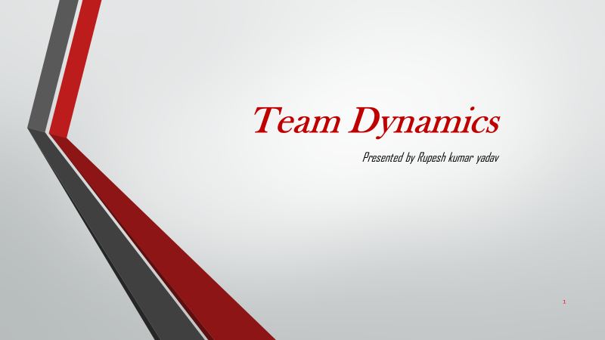

Figure presentation slide 1

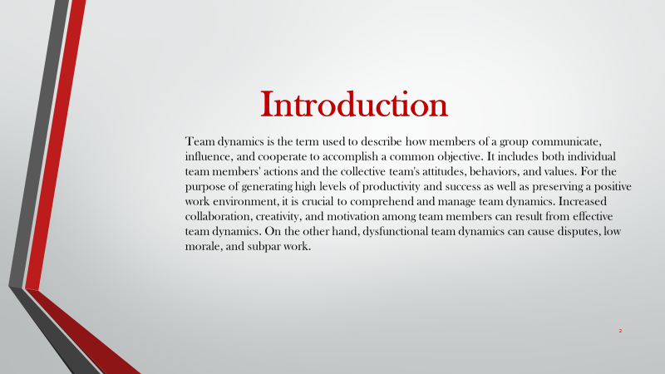

Figure presentation slide 2

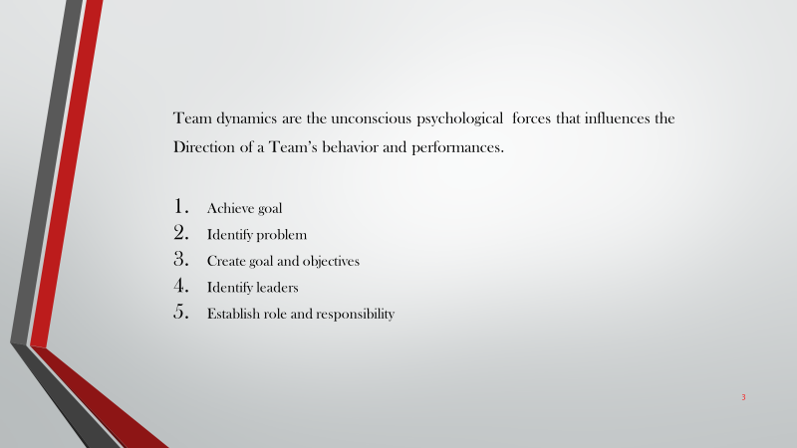

Figure presentation slide 2

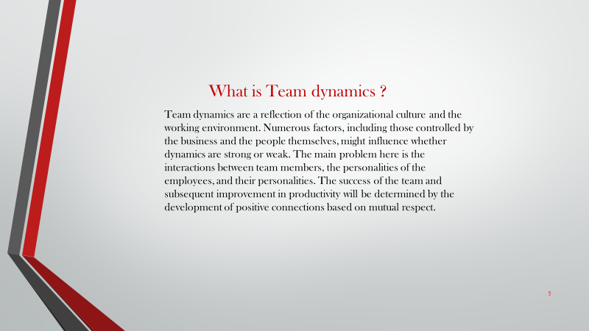

Figure presentation slide 4

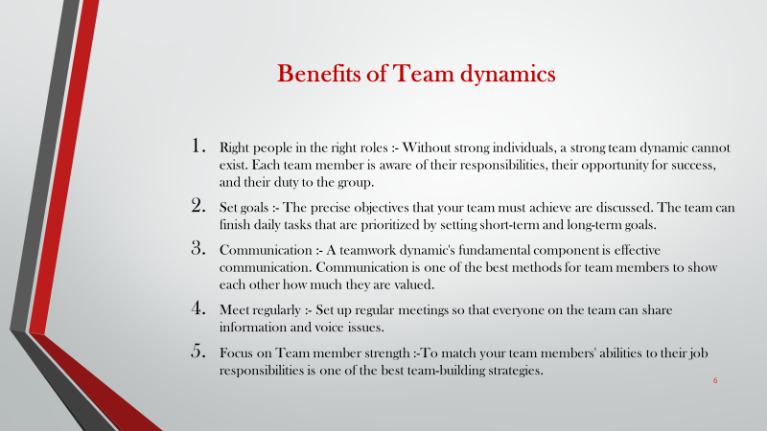

Figure presentation slide 5

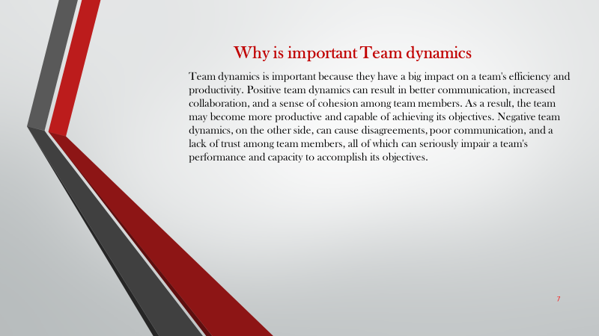

Figure presentation slide 6

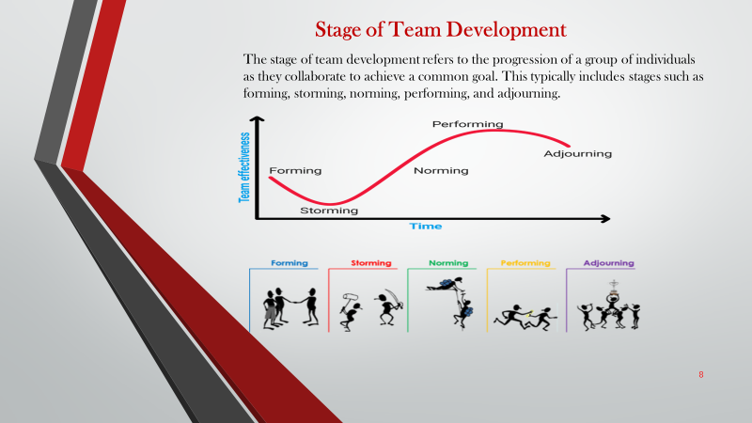

Figure presentation slide 7

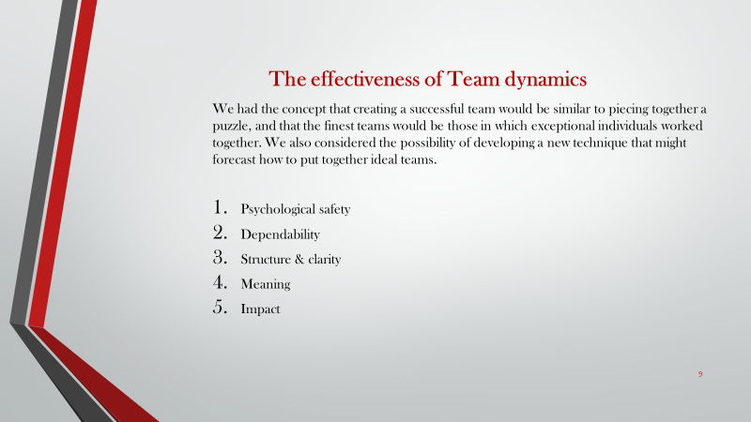

Figure presentation 8

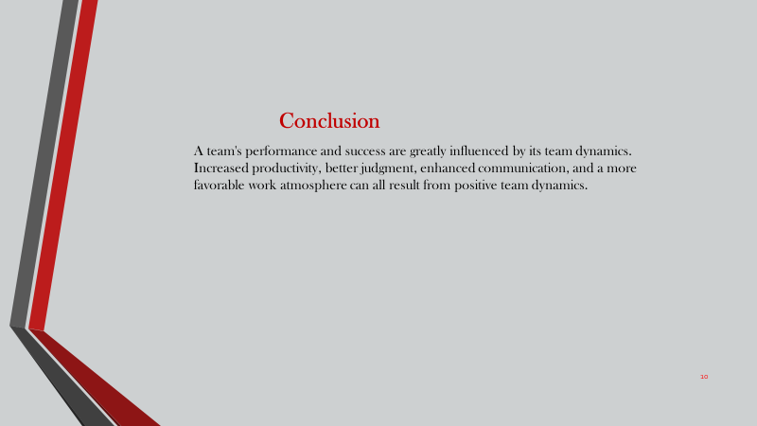

Figure presentation slide 9

# Importance of team dynamics in success of group work

Team dynamics is one of the most important things in group work. A team is a set of one or more people or the collection of people having a different idea, thought and views. The team works together towards achieving their certain needs. While performing teamwork to get success we must be considered different things of team dynamics they are:

**Interdependence**

To achieve a team goal, mutual understanding among group members is critical. Workplace success is aided by a high level of interconnectedness. As a result, dependency is critical in the establishment and operation of teams.

**Goal specification**

A group is created to achieve a specific aim. And the team should pay a higher importance to certain goals in order to achieve success. Identification of the objective is crucial since it inspires members to concentrate on the tasks that must be completed in order to achieve success.

**Trustworthiness**

Each member of the team should be truthful and honest with one another. This is beneficial to the group since it keeps their project schedules on track. Trusting one another expedites the group's progress to the performing level. The ability to maintain clear and effective communication among group members is aided by the members' trust and believe in one another.

**Cohesiveness**

It's a method in which the group's skills and abilities aid in achieving peak performance. It is interpersonal attraction that binds a group together. Every member of the team should feel a sense of belonging.

**Better decisions**

Team dynamics related to employees in making better decisions in order to reach a specific goal. Everyone in the group should have a "we" mentality rather than a "me" mentality. However, if the organization's leader becomes self-centered and refuses to listen to the members of the group before making his or her own choice, there will be conflict inside the group, which will lead to failure. As a result, a team leader should pay attention to each member's decision and make better decisions in order to achieve success.

**Communication**

Team coordination is greatly helped by good communication among team members. In a team dynamic, good communication aids in the formation of a strong bond among team members, and all thoughts and opinions are exchanged.

## Importance of team dynamic

In team dynamics, individuals interact successfully in making important decisions. When a group of people works together, the decisions they make are impacted by more than just the individual decision-making process. It has a significant impact on the quality and originality of their decisions. As a result, team interactions are crucial.

## Responsibilities and Work of our team members

We planned to organize a conference on science and medicine. Our lecturers and colleagues fully support our training initiatives. In science and medicine, space exploration includes studying the effects of space travel on human physiology and performance, developing countermeasures to prevent the detrimental effects of spaceflight on the human body, and developing medical procedures and technology for use during spaceflight.

* Team Leader: Mr. Sanjit Malla
* Scientists: Mr. Pemba Tamang
* Engineers: Mr. Dipesh Neupane
* Medical Doctors: Mr. Shomesh verma
* Data Analysts: Mr. Anit Tamnag
* Communication and Public Outreach: Mss. Prakriti shrestha

## Team Leader

The team leader is responsible for overall project management and coordination, including setting goals and objectives, assigning roles and responsibilities, and ensuring that the team is working effectively and efficiently.

## Scientists:

Scientists are responsible for conducting research, analyzing data, and developing new theories and hypotheses related to the effects of space travel on human physiology and performance, and the development of countermeasures to prevent negative effects.

## Engineers

Engineers are responsible for designing, developing, and testing medical equipment and technology for use during spaceflight, such as medical kits and diagnostic tools.

## Medical Doctors:

Medical doctors are responsible for assessing the medical needs of space travelers and providing medical care during spaceflight, as well as conducting research on the effects of space travel on human health.

## Data Analysts:

Data analysts are responsible for collecting, analyzing, and interpreting data related to the effects of space travel on human physiology and performance, and the development of countermeasures to prevent negative effects.

## Communication and Public Outreach:

Team members responsible for communication and public outreach would be responsible for communicating the team's findings and research to the public, as well as communicating with other teams and organizations working in the field of space medicine

## My role in a team

* I would be responsible for the following as a project manager for a group working on space exploration and science medicine:
* Establishing the project's aims and goals To make sure that everyone is aware of what needs to be done, you would work with the team to set precise and measurable project goals.
* Creating detailed project plans that include the tasks, materials, and schedules required to achieve the project's objectives: You would create thorough project plans outlining the duties, materials, and deadlines necessary to accomplish the project's objectives. Controlling the project budget and ensuring that resources are used properly and efficiently will fall within your purview.
* Managing teamwork is responsible for managing teamwork, which includes assigning assignments, monitoring progress, and addressing any problems that may occur.
* Communicating with stakeholders, such as team members, sponsors, and other stakeholders, to keep them informed of the project's status is the responsibility of the interaction with stakeholders.
* Managing the risks associated with identifying and controlling project risks, as well as creating and carrying out risk management plans.
* Ensuring that the project conforms with all relevant laws, rules, and standards, especially those that do with ethics and safety.
* Project management and reporting is in responsible of compiling and evaluating data, creating presentations and reports, and providing regular updates on the project's status.

## Area of development in my role:

Some important areas of development for a project manager of a science and medicine-related event to concentrate on include gaining a thorough understanding of the most recent advancements and trends in the industry, developing project management skills, managing budgets, creating marketing and communication strategies, managing vendors, analyzing and reporting on data, leading and managing teams, and recognizing and mitigating risks. You will be well-equipped to design and carry out an event that successfully promotes space exploration, science, and medicine while engaging the appropriate stakeholders if you master these skills.

## My contribution to sharing the goal

As a project manager, one's responsibilities include establishing clear goals and aligning the team, managing resources effectively, budgeting and forecasting revenues and expenses, developing marketing and communication strategies, coordinating the work of the team and vendors, analyzing and reporting on data, managing and leading the team, and identifying and mitigating risks. The project manager can successfully deliver an event in the fields of science and medical by concentrating on these areas and ensuring that it satisfies the objectives, spending constraints, and expectations of the stakeholders.

## Failure of group work in conference

There are many reasons why group work can go wrong, but some typical ones include unclear objectives and expectations, ineffective communication and coordination among group members, and a lack of accountability. Group members may become confused and miscommunicate, which can cause delays and blunders, when they are unsure of what is expected of them. Additionally, it might be challenging to keep on track and finish the project on time if group members are not cooperating or communicating well. Additionally, failure to hold group members accountable for their contributions might result in a lack of desire and apathy for the project. Each of these elements may play a role in the failure of cooperative projects. Members of the group must establish clear objectives and expectations, create efficient communication channels, and hold one another accountable for their contributions if they are to avoid these issues.

## Objective on achieving goals to make successful conference

The main goal of a good conference is to make sure that every participant has a fruitful and educational experience. This can be done by thoughtfully preparing the event, which includes choosing a suitable location, putting together a thorough schedule, and inviting pertinent and competent speakers. In order to draw a varied and active audience, it is also critical to successfully promote the conference. The conference can also act as a forum for participants to meet with industry professionals and learn about fresh advances in their sector by offering networking opportunities and encouraging a friendly and inclusive environment. In general, attendees of a successful conference should walk away with fresh perspectives and ideas as well as a sense of belonging and connection with their colleagues.

# Interpersonal skills

It is the ability to interact with others in a polite manner. It encompasses a wide range of abilities, including body language, time management, confidence, and so on. Listening, questioning, and reading body language are all part of it. A team, in general, requires a member with strong interpersonal skills. It is quite beneficial to our career. Interpersonal skills let us interact with the students we met throughout the training event as we were designing and delivering it.

## Effectiveness and application of interpersonal skill

The written analysis of efficacy and the application of interpersonal skills throughout the planning and delivery of a training event are described in this section. During the event, there was contact between us and the students. There was communication between us and the students while the students were paying attention to us during the event. We were able to communicate both verbally and nonverbally. While we were speaking orally through speeches and papers, we were also communicating non-verbally through eye contact, facial expressions, and limb movements throughout the event. Because of the efficiency of interpersonal skills, we were able to communicate with the students, which helped in our personality development.

Likewise, our group members were involved in teamwork, which helped us in collaborating with one another. Initially, we had some issues about arranging the event, but our creative thinking and interpersonal abilities enabled us to fulfill our task of correctly and successfully managing the event. It helps us in achieving our goal and fulfilling our group responsibilities. Interpersonal skills, as well as the necessity of leadership, help in the achievement of the event's goal. The importance of leadership and time management abilities influenced our teamwork.

# Conclusion

Overall, we all cooperated and successfully completed our training exercise as a team. This experience taught us that working together in a team is more effective and necessary to accomplish a task. Being a team player and working in a team has also been advantageous. I learned from this experience how important it is for a group to collaborate in order to achieve a common goal. Teams succeed or fail based on how well they interact with one another. As a result, team dynamics are crucial to determining whether a team succeeds or fails in reaching a common objective.

# Activity 3

# Introduction

Continuing professional development, or CPD, refers to the deliberate, ongoing, and lifetime process of learning that people do with the aim of preserving and modernizing the abilities that support their professional lives. The learning activities that stretch students' knowledge and skills include attempting something new and talking about it with the teacher. It is a methodical way of learning knowledge, abilities, and practical experience.

The majority of us have heard of CPD, or "continuous professional development," in our professional life, but we rarely seem to engage in it as regularly as we'd like to. The cited source is incorrect.

# Continuing Professional Development (CDP)

Continuing Professional Development (CPD) is the continuous learning and development that individuals engage in to maintain and improve their knowledge, skills, and abilities in their professional field. Attending conferences, workshops, seminars, or online training; taking classes or earning degrees; or engaging in independent study or research are all examples of CPD. CPD aims to keep professionals current in their field and capable of adapting to new developments and changes in their industry. CPD is required in many fields for professionals to keep their licenses or certifications.

## Importance of CDP

CPD is important for a variety of reasons. Among the primary advantages are:

* Keeping current: Continuing professional development (CPD) helps professionals stay current on the latest developments and changes in their field, which can be critical for remaining competitive and relevant in today's rapidly changing job market.
* Developing new skills and improving existing ones: CPD can assist professionals in developing new skills and improving existing ones, which can lead to improved performance in their current job and increased career opportunities in the future.
* Meeting professional requirements: Continuing education is required in many fields for professionals to keep their licenses or certifications. Professionals may be unable to practice in their field if they do not participate in CPD.
* Personal development: CPD can help people grow both professionally and personally. It can also help to increase self-confidence and self-esteem by allowing you to discover new interests and passions.
* Networking opportunities: Professionals can connect with others in their field through CPD events and activities, which can lead to new collaborations, partnerships, and job opportunities.

Overall, CPD assists professionals in remaining current, competent, and engaged in their field, which can lead to improved job performance, expanded career opportunities, and better outcomes for their clients or employers.

# Motivation contribution to own learning.

I Could help my own CDP learning and motivation by doing the following points:

* Set specific CDP-related learning objectives for yourself, such as understanding the technical capabilities of various CDP solutions or learning how to effectively use a CDP to improve customer engagement.
* Find a mentor or colleague with CDP experience and ask them to share their knowledge and insights with you.
* Participate in CDP-related projects or initiatives at work to put your knowledge to use.
* Seek opportunities to share your CDP research and insights with others, such as giving a presentation at a company meeting or writing an article for an industry publication.
* Stay motivated by remembering the potential benefits of CDPs, such as increased revenue and improved overall customer experience.
* Understand the potential of CDPs by understanding the use cases and potential benefits for your company.
* Connect with other professionals in the field through networking events, online communities, or industry groups to learn from their experiences and stay motivated.
* Continuously seek out new learning opportunities, whether through webinars, conferences, or workshops, or through online courses.

By setting clear goals, seeking opportunities to apply your learning, and remaining motivated, you can contribute to your own professional development and mastery of CDPs, and be well-prepared to capitalize on the benefits it can bring to your business.

# Motivational Theory

There have been several proposed motivational theories to explain why and how people are motivated to engage in certain behaviors. Among the most well-known and widely studied theories are:

## Maslow's Hierarchy of Needs:

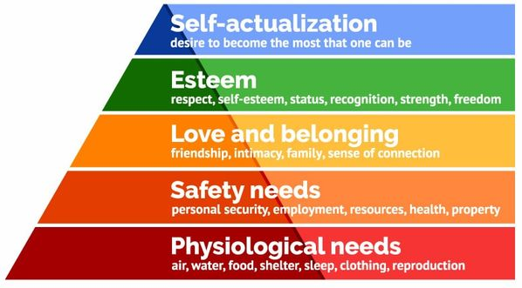

Our most basic need is for physical survival, and this will be the first thing that motivates our behavior. Once that level is fulfilled the next level up is what motivates us, and so on.

1. These are biological necessities for human survival, such as air, food, water, shelter, clothing, warmth, sex, and sleep.

The human body cannot operate at its peak potential if these needs are not met. Maslow deemed physiological needs to be the most critical because, until these needs are satisfied, all other needs are subordinate.

1. Needs for safety and security - after a person's physiological needs are met, these needs start to stand out. People seek out order, predictability, and control in their daily lives. The family and society can provide for these requirements (e.g. police, schools, business and medical care).

For instance, psychological safety, monetary safety (e.g., employment, social welfare), legality, safety from harm, social stability, property, health, and wellbeing (e.g. safety against accidents and injury).

1. After one's physical and safety needs are met, one's need for love and a sense of belongingness comes into play. This is the third level of human needs. A human being's emotional need for interpersonal connections, affiliation, connectedness, and group membership is known as belongingness.

Friendship, intimacy, trust, acceptance, receiving and giving affection, and love are a few examples of belongingness needs.

1. The Maslow hierarchy's fourth level, esteem needs, includes self-worth, accomplishment, and respect. Maslow divided esteem needs into two categories: the need for respect or reputation from others, and the need for respect for oneself (dignity, achievement, mastery, independence) (e.g., status, prestige).

According to Maslow, the need for reputation or respect is more crucial for kids and teenagers than the need for genuine self-worth or decency.

1. The highest level in Maslow's hierarchy, self-actualization needs, are concerned with realizing one's potential, finding contentment in oneself, seeking personal development, and having peak experiences. This level, according to Maslow is the drive to achieve one's full potential and maximize one's potential.

People may focus or perceive this need very specifically. One person could, for instance, have a tremendous desire to become the perfect parent. In another, the urge could manifest itself in the arts, sciences, or sports. Others could use art, such as paintings, photographs, or inventions, to express themselves artistically.

## Impact on workplace

* The social side of the job and a sense of security both serve as motivators for the employee.
* It will significantly help them in resolving issues in a challenging economic environment.
* The employee will be rewarded for his or her efforts or will strive to be rewarded.
* The worker will be able to develop professionally while working.

## Two-Factor Theory of Herzberg:

People are motivated by two types of factors, according to this theory: hygiene factors (such as pay and working conditions) and motivators (such as achievement and recognition).

According to the dual-factor theory, which is also known as Herzberg's motivation-hygiene theory, there are two distinct sets of workplace elements that can either lead to job satisfaction or job unhappiness (Herzberg, 2021). The two-factor hypothesis was proposed by American psychologist Frederick Herzberg. Motivators and cleanliness form the basis of this philosophy. The motivation at work can be better understood thanks to this notion. The two components of this hypothesis have an effect on workplace motivation. One of these components is Salary, compensation, and working conditions are examples of hygiene elements, whereas personal success, status, development, opportunity, and responsibility are examples of motivators.

Impact on Workplace

* Increased employee status, security, good working relationships with supervisors and coworkers, and a reduction in bureaucracy are all aided by hygiene aspects.
* The motivational factor guarantees that workers may reach their objectives, receive recognition, develop, and learn on the job.

## The McClelland Theory of Need

The McClelland Theory of Needs can have an impact on how you establish objectives, offer criticism, inspire team members, and give rewards. Additionally, you may utilize these inspirations to design work that accommodates the limbs (Georgia, 2021). Because McClelland held that people learned or acquired their needs as a result of the sorts of experiences they had in their surroundings and society, this theory is also known as the Acquired-Needs Theory. This notion is necessary for satisfying desires, upholding positive connections, influencing others, and influencing people's opinions.

Impact on the workplace

• This theory ensures that employees have a strong desire to take personal responsibility for performing a task in order to solve a problem.

• Employees tend to set difficult goals, achieve them, and take calculated risks.

• Employees are concerned about maintaining leader-follower relationships.

• Employees will value the feelings and thoughts of their coworkers and supervisors.

## Vroom’s Expectation Theory

Along with Edward Lawler and Lyman Porter, Vroom's expectation theory makes the assumption that conduct is the outcome of intentional decisions made between alternatives with the intention of maximizing pleasure and avoiding pain. Victor Vroom postulated that, contrary to what other scientists had previously believed, there was not a straightforward correlation between how individuals behaved at work and its objectives. Vroom acknowledged that a worker's performance is influenced by human characteristics including personality, skills, knowledge, experience, and talents (Tarrant, 2021). Victor Vroom established this idea on the fundamental presumption that individuals will be driven to put up a high degree of effort when they feel there is a connection between the effort they make and the results/rewards they obtain, according to Mark.

Impact on Workplace

* It has a positive impact on the workplace because it ensures that achievable goals are set for your employees and that they receive the rewards that they desire.
* Employees can be motivated to work hard for the company by using a reward system.

# Impact of CDP in my workplace

Continuing professional development (CPD) can improve workplace performance by assisting individuals in staying current with industry trends and developments, acquiring new skills, and expanding their knowledge and expertise in their field. This can lead to increased productivity, better job performance, and greater job satisfaction. CPD can also help people advance in their careers and earn more money. Furthermore, CPD can help organizations attract and retain talented employees, improve the skills and knowledge of their workforce, and remain competitive in their industry. Overall, CPD can be a valuable investment for both individuals and organizations, as it can lead to improved performance and long-term success.

# Development plan that outlines Responsibilities

According to the scenario, I've been working as an intern in an IT company, and I need to create a development plan that outlines my specific responsibilities and performance goals. Furthermore, I need to clarify the skill set required for my job.

In order to achieve the outcomes necessary in your profession and in life in general, you should consider what talents you need to improve personally, advises Rachel Matthews. It involves expanding your abilities both within and outside of the job. It is the process of structuring a plan and creating its goals and objectives. The development strategy has been more successful in handling the needs of that yeti explorations growth throughout my internship there. It is important to consider how the current business plans to grow and continue to meet the needs of its clients in the future.

It also comprises determining my talents and implementing certain education, training, courses, and workshops to support the growth of your knowledge and skills. I need extra possibilities for technical growth, such as networking, software development courses, webpage development courses, etc., as an intern at an IT firm. Plans for developing one's interpersonal, employability, and communication skills are also necessary.

# Responsibilities

• To complete all work and tasks by the deadline.

• Creating a peaceful working environment.

• Interaction with various types of staff, including managers and team leaders.

• Respecting every employee's idea and thought.

• Be on time.

• Increasing knowledge and passing it on to new and inexperienced employees.

# Development plan table

|  |  |  |  |  |  |
| --- | --- | --- | --- | --- | --- |
| **S. N** | **Skills and knowledge** | **Current Proficiency** | **Plans for development** | **Duration** | **Intended result** |
| **1.** | Technical skills | 1. 1. Solid foundational knowledge. 2. 2. low in terms of networking. 3. 3. Programming ability is average. 4. 4. Low on the webpage development. | 1. 1) Enrolling in computer classes 2. 2) Studying various programming languages. 3. 3) Studying networking, databases, servers, and so on. 4. 4) Completing advanced computer courses | 6 months | . Will be able to perform programming tasks and apply logic.  Be able to network and manage databases.  Be able to create websites |
| **2.** | Employability skills | 1. 1. Lack of self-assurance. 2. 2. Inept at negotiating with others. 3. 3. Ordinary communication 4. 4. Good command of the English language | 1. 1) Enrolling in public speaking classes. 2. 2) Attending various conferences and seminars. 3. 3) Enrolling in an advanced English course. 4. 4) Socializing with successful people. | 9  months | Will be able to bargain with others.  Be self-assured.  Fluency in English is required... |
| **3.** | Time management skills | 1. 1. There are no time management strategies. 2. 2. Punctual. 3. 3. Average at completing tasks ahead of schedule. | 1. 1) Developing time management strategies and a plan. 2. 2) Establishing a daily routine that is punctual. 3. 3) Creating a to-do list. | 7  months | Be able to stick to time management plans.  Be able to complete the task before the deadline. |
| **4.** | Social skills | 1. 1. It is less cultural. 2. 2. I'm terrible at joining functions and programs. 3. 3. Little interaction with others. | 1. 1) Make an effort to be cultural. 2. 2) Participating in all societal functions and programs. 3. 3) Begin interacting with your neighbor. | 3 months | Be able to form positive relationships with the people in a society. |
| **5.** | Research and analyzing skills | 1. 1. Researching ability is average. 2. 2. Poor at analyzing | 1. 1) Taking part in a survey. 2. 2) Begin watching suspense films and reading books. 3. 3) Begin participating in people's problems. | 5 months | . To be able to conduct thorough research.  To be able to conduct any type of analysis |

## Roles of CDP

Continuing professional development (CPD) is essential for professionals to maintain and improve their knowledge and skills in their respective fields. CPD assists professionals in staying up to date on the latest developments and advancements in their industry, allowing them to provide better service to their clients or customers. CPD can also help professionals meet professional body requirements, such as licensing or accreditation, and maintain their professional standing. CPD can also assist professionals in improving their employability and advancing their careers. It can also be used to gain peer recognition and credibility. CPD, in general, assists professionals in remaining competent, confident, and effective in their roles.

Some of the points are given below

* Maintaining and improving knowledge and skills: CPD helps professionals stay current on the latest developments and advancements in their industry, allowing them to provide better service to their clients or customers.
* Meeting professional requirements: CPD can assist professionals in meeting professional body requirements, such as licensing or accreditation, and in maintaining their professional standing.
* CPD can help professionals improve their employability and advance their careers. It can also be used to gain recognition and credibility among peers.
* Staying competitive: Continuing education can help professionals stay competitive in their fields by keeping them up to date on new technologies, trends, and best practices.
* CPD can help professionals develop new skills and gain new perspectives on their profession, leading to increased job satisfaction and personal growth.
* Networking: Professionals can use CPD events to connect and network with other professionals, which can lead to new business opportunities and collaborations.

# Development planning in building motivational

By setting clear goals and providing a clear path to achieve them, development planning can play an important role in increasing employee motivation. Employees are more likely to feel motivated to work toward their goals when they have a clear understanding of what they need to do to advance in their careers.

* Setting clear goals: Development planning can help employees understand what they need to do to advance by setting specific, measurable, attainable, relevant, and time-bound (SMART) goals.
* Giving employees a clear path to advancement: Development planning can help employees understand the steps they need to take to advance in their careers, which can increase their motivation to work toward those goals.
* Encourage employee ownership: When employees are involved in the development planning process, they are more likely to take ownership of their goals and feel motivated to achieve them.
* Facilitating learning and development: Development planning can help employees develop new skills and knowledge while also feeling more motivated to advance in their careers.
* Recognizing and rewarding progress: Recognizing and rewarding progress toward development goals can help employees feel motivated to continue working toward those goals.

# Conclusion:

CPD inspires us to work toward our goals and helps us develop our talents. Businesses are increasingly interested since it increases public confidence while also fostering the growth of future-relevant skills, knowledge, and careers. Future professional development or modifications are aided by CDP. Additionally, CPD supports the growth of particular traits and abilities, as well as the enhancement of an employee's job performance and the realization of their full potential at work, all of which are advantageous to the business and improve an organization's or company's welfare. As a result, businesses of all sizes should invest time and money in the continued professional development of their personnel.

# References

CFI. (2022, April 21). *CFI* . Retrieved from https://corporatefinanceinstitute.com/resources/knowledge/other/maslows-hierarchy-of-needs/

Georgia. (2021, August 26). *P and T*. Retrieved from https://psychotreat.com/mcclellands-theory-of-needs/

Herzberg. (2021, November 16). *Simply Phycology*. Retrieved from https://www.simplypsychology.org/herzbergs-two-factor-theory.html

Keiling, H. (2019, February 28). *indeed*. Retrieved from https://www.indeed.com/career-advice/career-development/nonverbal-communication-skills

Nordquest, R. (2019, september 19). *ThoughtCo*. Retrieved from https://www.thoughtco.com/what-is-communication-1689877

*Simplilearn*. (2021, February 24). Retrieved from https://www.simplilearn.com/what-is-problem-solving-article

Tarrant, G. (2021, August 26). *P and T*. Retrieved from https://psychotreat.com/vroom-expectation-theory/

Tiwari, S. (2022, March 23). *DIGIAIDE*. Retrieved from https://digiaide.com/verbal-communication/